**Address:**

To: Dr. Christopher Peters and Mr. David Cinciruk

From: Philip Mak and Sancheet Hoque

Date: 5/3/2019

Re: Lab 3

**Introduction**

The purpose of lab 3 was to measure the voltage and current of a battery discharging, in which students can calculate the power and cumulative energy. The whole idea was to have a 9V battery power a DC motor, but stop after it falls underneath 4.8V. This motor will be a part of the cooling system for the electrical vehicle model. It is controlled by the arduino, which sends a signal based on the RPM of the motor whether or not to activate the fan.

**Method/Analysis**

The circuit for discharging a battery started by switching out the DC power supply for a small 9V battery. Two batteries were used: one for testing the code and the other for discharging all the way down to 4.8V. Students added the oscilloscope in parallel with the battery to measure voltage and the multimeter in series with the positive output of the battery to measure current. A small capacitor was attached across the DC motor in order to negate the noise of the DC motor for more steady measurements.

In order to retrieve the data as the battery was discharging, the oscilloscope and multimeter were automated in Matlab to measure the max voltage and current respectively each second. The time variable was measured after a 1 second pause between each measurement. However, there was uncalculated processing time from adding the data to each array. This provided us with three arrays: Voltage, Current, and Time. The power and cumulative energy over time was calculated by using P=I*V and E=P*T respectively.This was plotted against time for both battery brands to use as a comparison against each other.

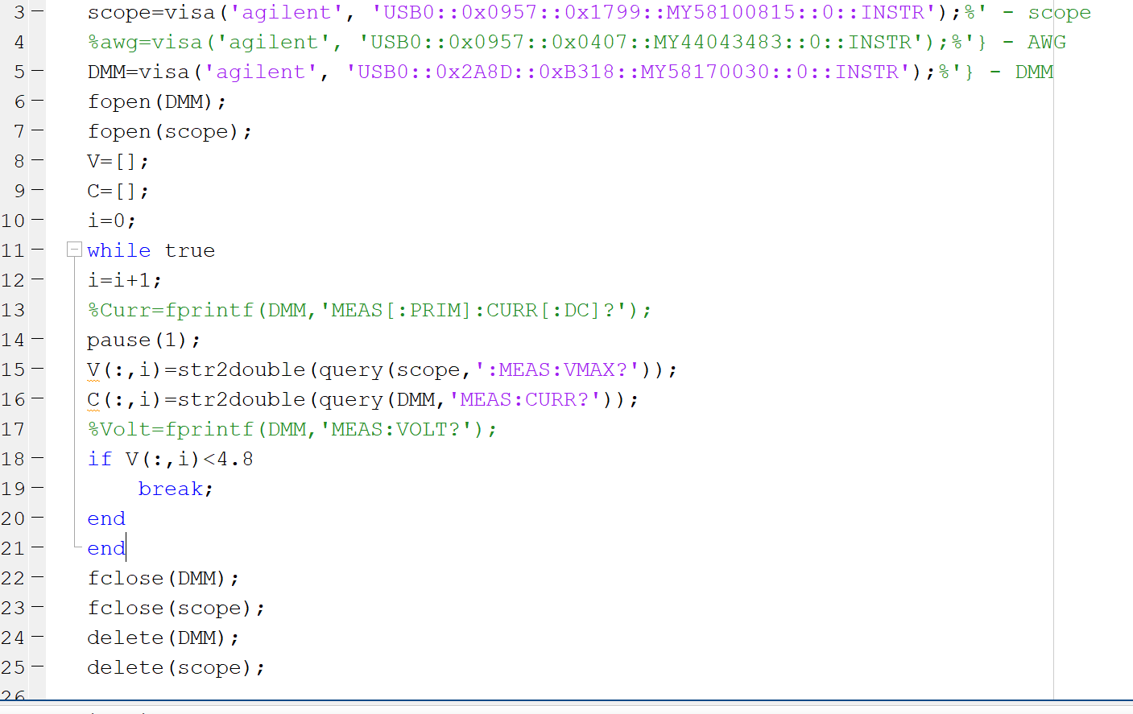

Figure I: Matlab code to retrieve voltage, current, and time

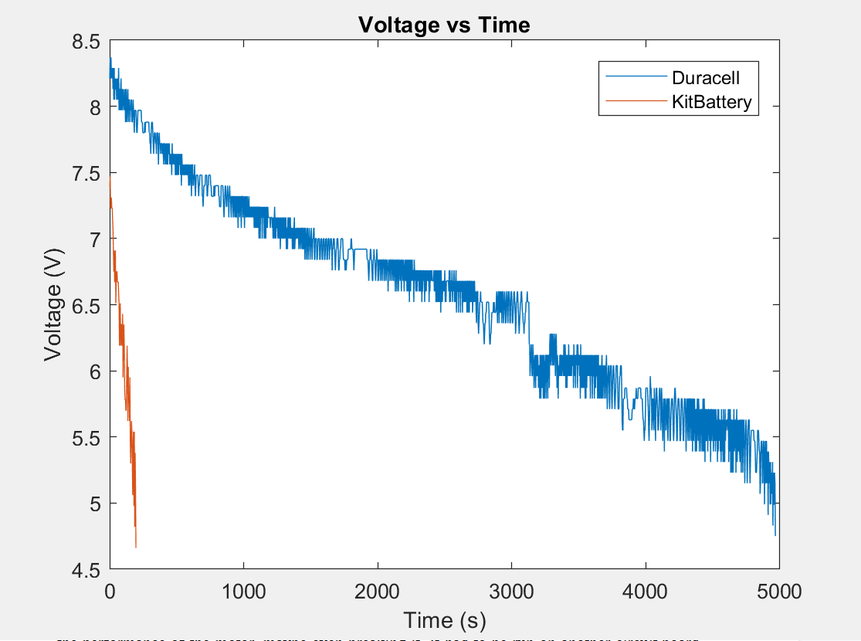

Figure II: Graph of the Two Batteries’ Voltage Over Time

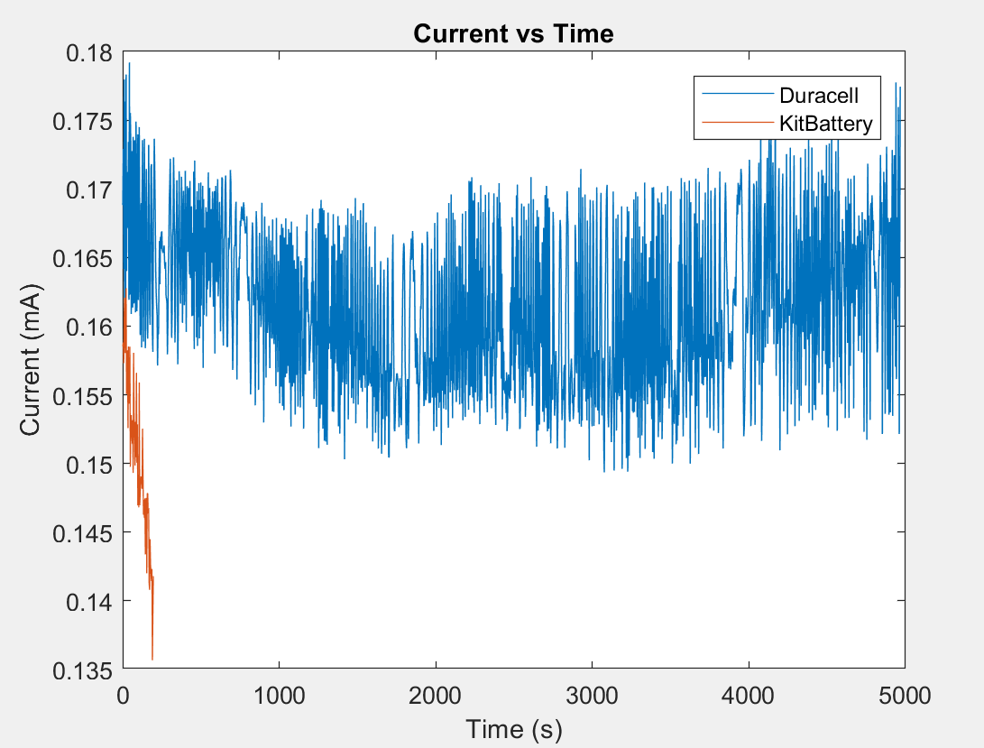

Figure III: Graph of the Two Batteries’ Current Over Time

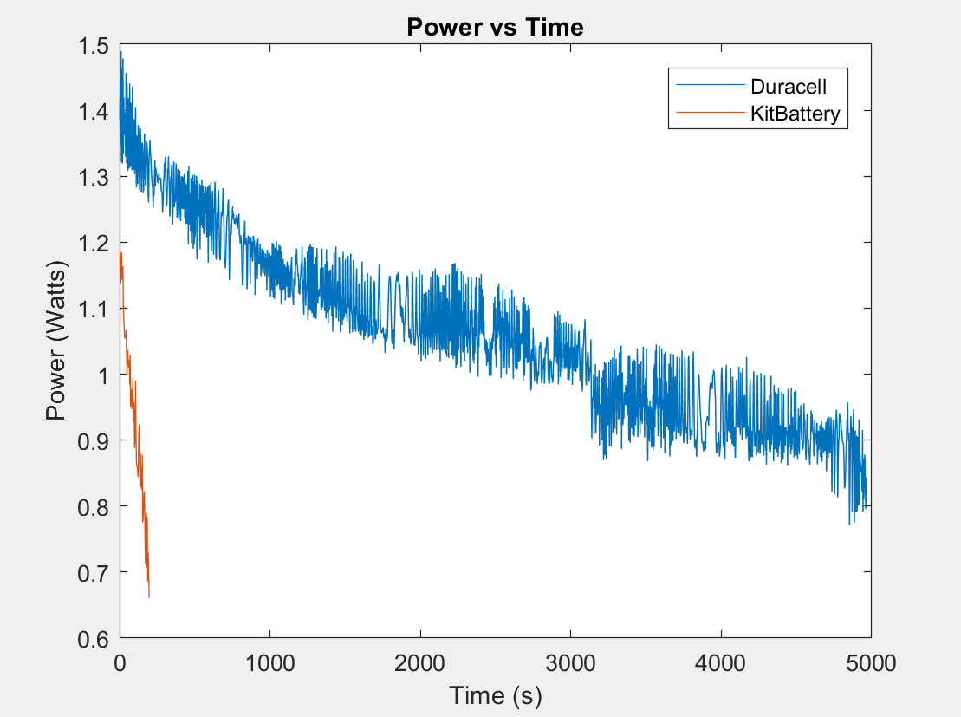

Figure IV: Graph of the Two Batteries’ Power Over Time

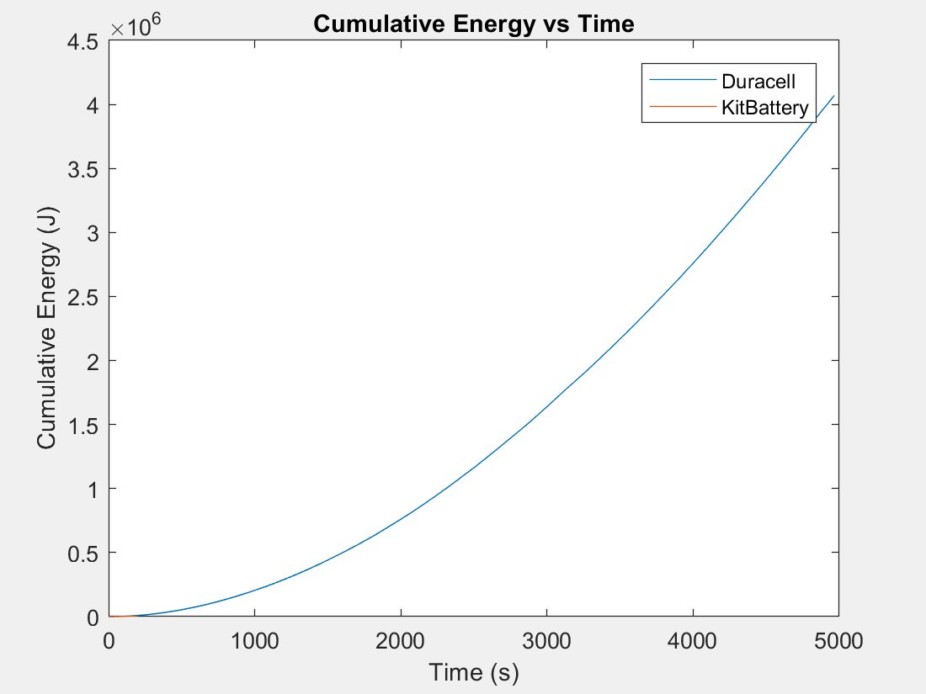

Figure V: Graph of the Two Batteries’ Cumulative Energy Over Time

A fan from the given kit was used along with a packaged circuit board. With power from an outlet, there was a 3.3V output on the circuit board to provide the small DC motor with a fan blade attached. It turns on based on a digital high or low from the Arduino based on the H-Bridge being above 50% maximum RPM**.** There was a 220Ω resistor added between the transistor and the digital input to minimize current when the input is low. The high and low capacitance capacitors were added to filter out the high and low noise to have a steady DC voltage to the motor. The small diode was to allow the charge to dissipate if the digital input is low. The arduino acted as the controller for the fan. The script for it stayed exactly the same as the other labs to run the motor, but in the mainloop, the RPM calculation is redone and acts as a switch to turn on the digitalWrite from low to high. The high digital output turns on the transistor, thus enabling the fan. It goes back to low once the RPM from the Hbridge is below 314 which was the peak value that was calculated from the previous lab

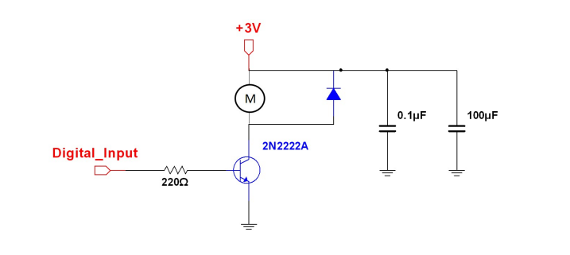

Figure VI: The Circuit for the Cooling Fan

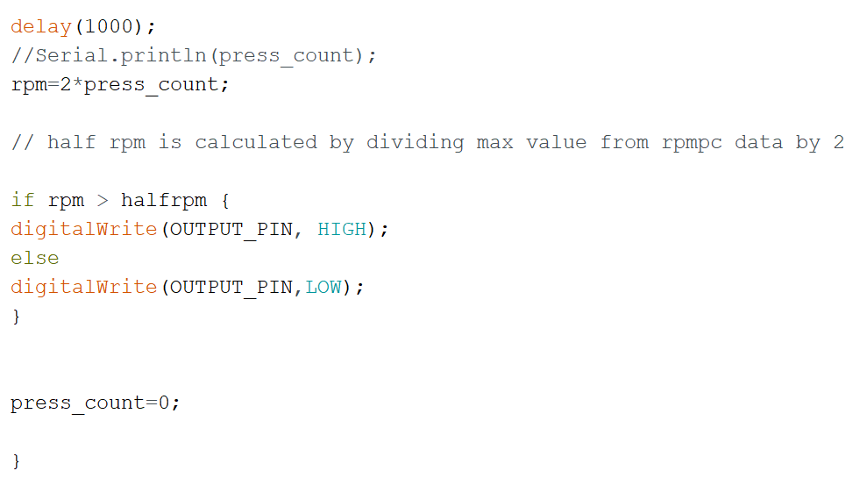

Figure VII: Arduino code to turn transistor on and off

**Discussion and Conclusion**

The ability to automate the measurement of power supplies, be it a dinky Duracell battery, never-dying Amazon Battery, or an outlet, is important. The car batteries are just as important as the fuel tanks of gasoline powered vehicles, so having a optimized motor with accurate measurements of runtime or performance is important so it doesn’t run out of power in the middle of nowhere.

A cooling system is key to a power supply as running a hot motor will have an adverse effect on the performance of the motor, maybe even breaking it. It had to be run on another circuit board to avoid potential noise between the cooling and rest of the system.

In hindsight, there was a lot of optimization choices students could’ve made in the discharge. One example is using “tic toc” for time measurements rather than a pause(1) and then i variable adding. This had some uncalculated processing time. However, students deemed their i variable to have a 3 second interval based on the start and end of the discharge. For future usage, tic toc should be used for accurate time interval measurements to avoid the difference in processing time beyond assigned pause times.